Agile assessment answers

1a last lo vundhii see

1b

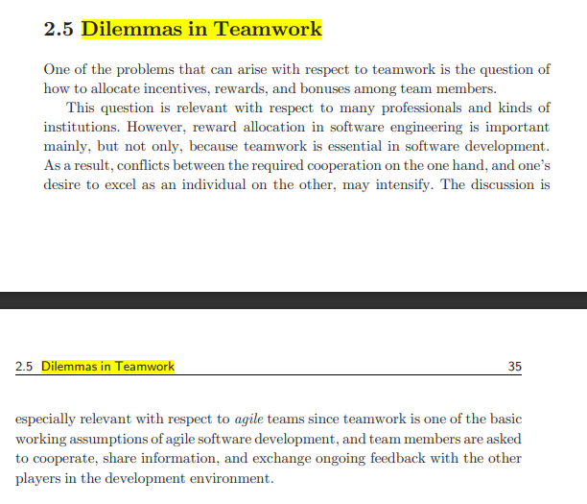

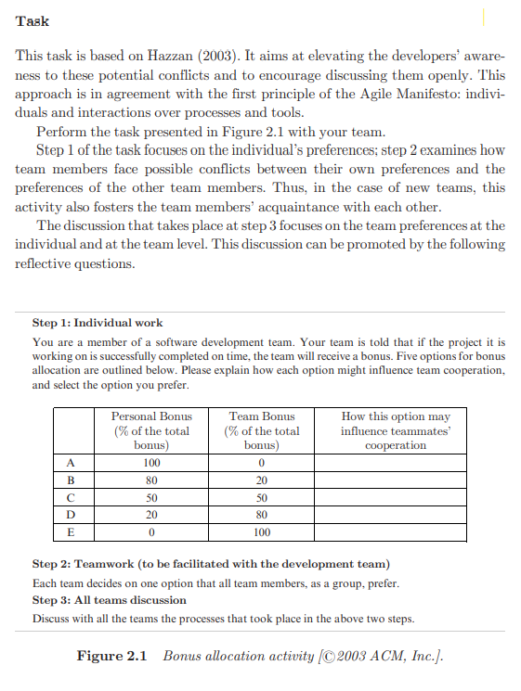

2a

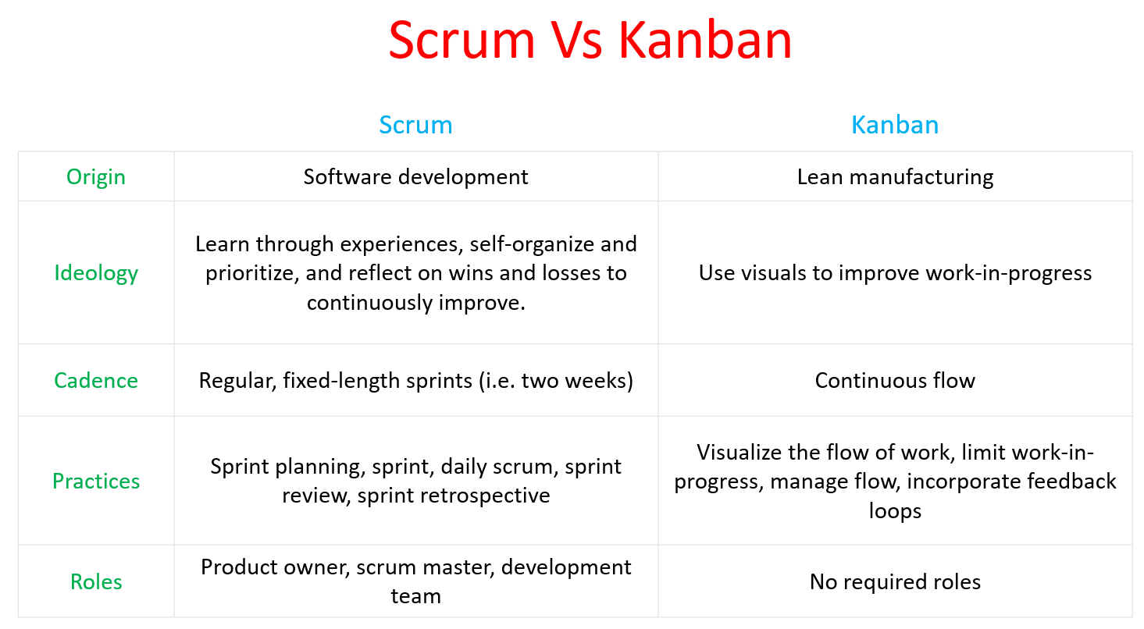

OICPR

**Scrum by Example** is written as an episodic story, with a small cast of characters and a simple fictional product. In each episode, there will be a breakdown of a specific problem or issue, as well as information and advice for how to handle it, whether you are a ScrumMaster or in any of the Scrum roles

**Kanban example :**

Giving a Project Manager Visibility into Status

Diagram laga geyalli ani na thinking like ela :

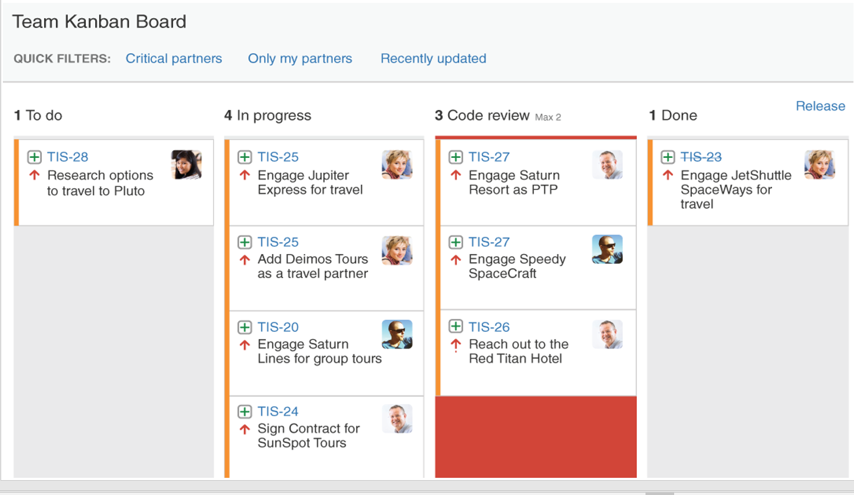

2b

Agile team is a cross-functional group of people that are organized to work collaboratively in order to deliver a product increment. Agile teams are faster and more adaptable than traditional project groups.

Agile teams are structured in a way that enables the team to be more responsive to change and more adaptable. This structure is based on the principles of self-organization and cross-functional work.

The roles in the Agile team are listed below.

1. Product Owner

2. Team Lead/Scrum Master

3. Development Team Members

4. Stakeholders

**Product owner**

The product owner represents the stakeholders of the project. The role is primarily responsible for setting the direction for product development or project progress.

The Product Owner understands the requirements of the project from a stakeholder perspective and has the necessary soft skills to communicate the requirements to the product development team. The Product Owner also understand the long-term business vision and aligns the project with the needs and expectations of all stakeholders.

The key responsibilities of a Product Owner include:

Scrum backlog management

Release management

Stakeholder management

**Team Lead/Scrum Master**

**T**he Team Lead or Scrum Master ensures team coordination and supports the progress of the project between individual team members. The Scrum Master takes the instructions from the Product Owner and ensure that the tasks are performed accordingly.

The role may involve:

# Facilitating the daily Scrum and Sprint initiatives

# Communicating between team members about evolving requirements and planning

# Coaching team members on delivering results

# Handling administrative tasks such as conducting meetings, facilitating collaboration, and eliminating hurdles affecting project progress

# Shielding team members from external interferences and distractions

**Development team members**

The team members within the Development Team are comprised of individuals with responsibilities including but not limited to product development. The team takes cross-functional responsibilities necessary to transform an idea or a requirement into a tangible product for the end-users. The required skills might be wrapped up in one or more dev team members:

Product designer

Writer

Programmer

Tester

UX specialist

**Stakeholders**

The Stakeholder position may not be directly involved in the product development process but is used to represent a range of key roles that impact the decisions and work of the Scrum team. The stakeholder may be:

The end user of the product

Business executives

Production support staff

Investors

External auditors

Scrum team members from associated projects and teams

3a

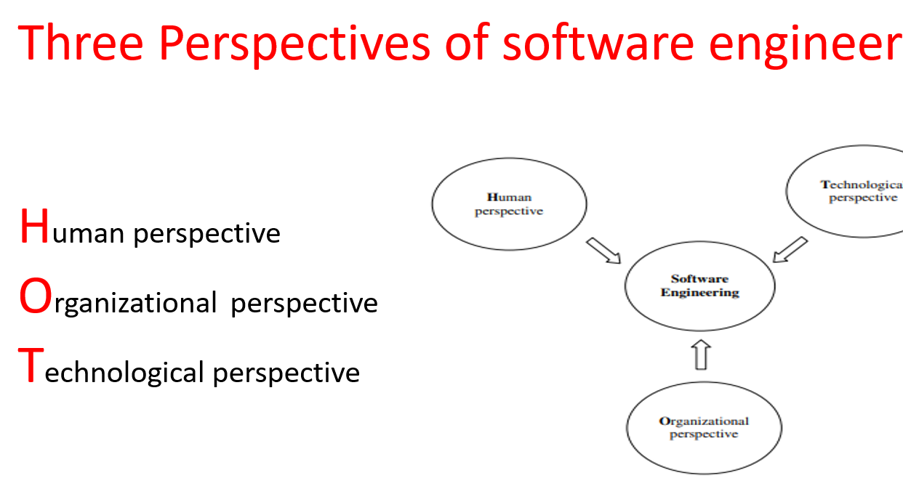

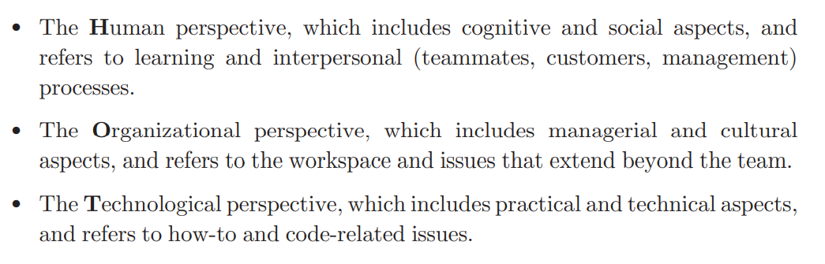

Understand chasukuni own ga ieyana rayachuu

Text book pag no :21

3b

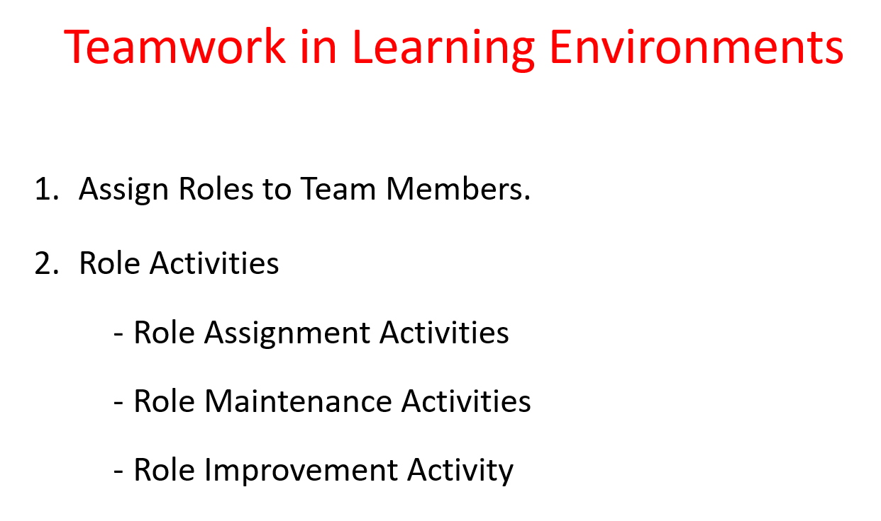

**Teaching and Learning Principle 7: Assign Roles to Team Members.**

According to this principle, each team member has both an individual role, chosen by the member from a given list (for example, coach, unit tester, acceptance tester, code reviewer, etc.), and development tasks for which he or she is responsible

**Role Activities**

**Role Assignment Activities**

The first two activities introduce the role scheme to the team members. If the activities are carried out in an industrial setting, they should be facilitated when the agile team is established, in order to let the team members feel the interconnection among themselves, and their mutual responsibility as an agile software development team.

**Role Maintenance Activities**

The activities in this part are performed on a regular (daily, weekly, iteration) basis. In academia this enables the academic coach to be aware of the project’s progress and to improve the students’ work assessment; in industry it enables the entire team to be aware of the project status.

**Stand-up meeting**: Stand-up meetings take place every day in industry, and on a weekly basis in academia. It can be decided that some portion of the brief personal report (one or two sentences) be dedicated to the personal role. Each team member reports about his or her role performance and about his or her expectations from teammates with respect to personal roles

**Presentations to customers:**

The following task fits for an academic setting; when appropriate, it can be adjusted for an industrial setting. Specifically, each presentation to the customer consists of two parts.

**Feedback after presentations:**

In academia, there are three presentations to the customer during the semester: at the seventh, eleventh, and fourteenth (the last) meetings .

**Role Improvement Activity**

The following activity can be requested by the academic coach periodically when she or he observes that it is needed. Such a need occurs mainly in cases when the academic coach feels that some roles are not being performed properly. The students are asked to summarize their role activities, to publish their summaries in the electronic forum, and to provide feedback to the summaries presented by the other team members.

4a

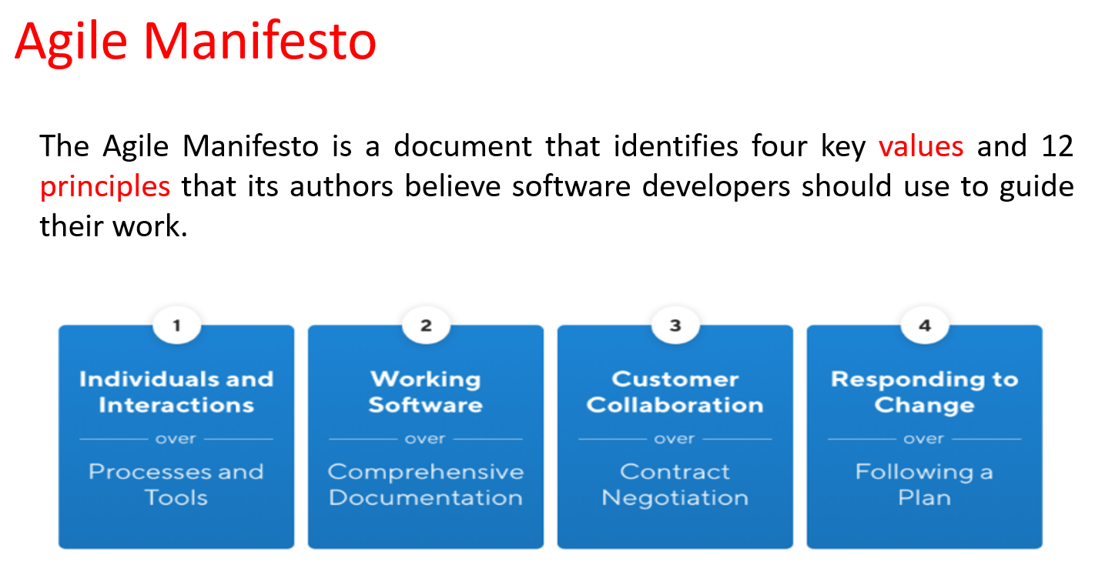

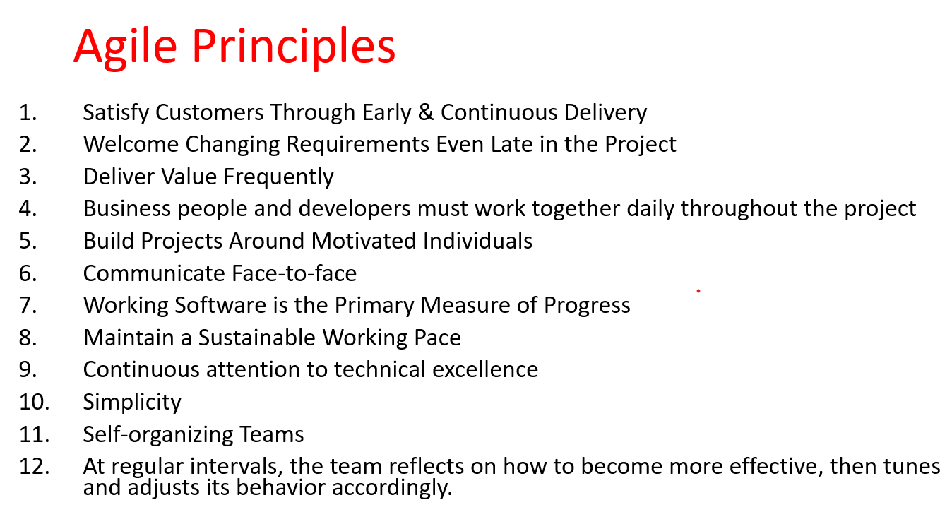

4b

**Uses of scrum :**

Quicker release of useable product to users and customers.

Higher quality.

Higher productivity.

Lower costs.

Greater ability to incorporate changes as they occur.

Better employee morale.

Better user satisfactio.

Being able to complete complex projects that previously could not be done.

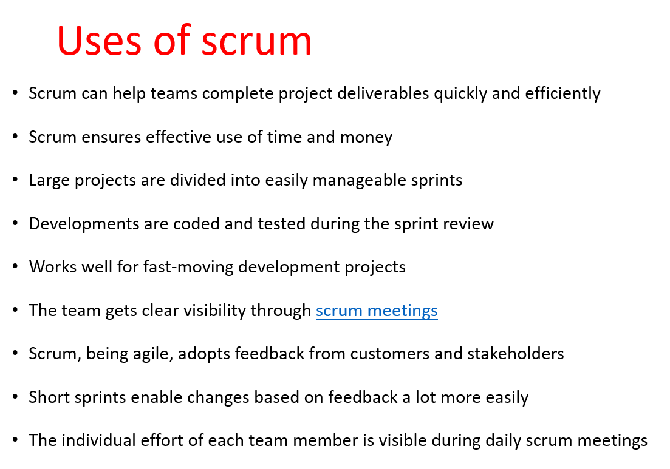

Any 6-7 rastheyy saripodhi emoo

1a

Non functional requirments :

**Security –**

The system uses SSL (secured socket layer) in all transactions that include any confidential customer information.

The system must automatically log out all customers after a period of inactivity.

**Reliability –**

The system provides storage of all databases on redundant computers with automatic switchover.

**Availability –**

The system should be available at all times, meaning the user can access it using a web browser, only restricted by the downtime of the server on which the system runs. In case of an of a hardware failure or database corruption, a replacement page will be shown

**Maintainability –**

A commercial database is used for maintaining the database and the application server takes care of the site

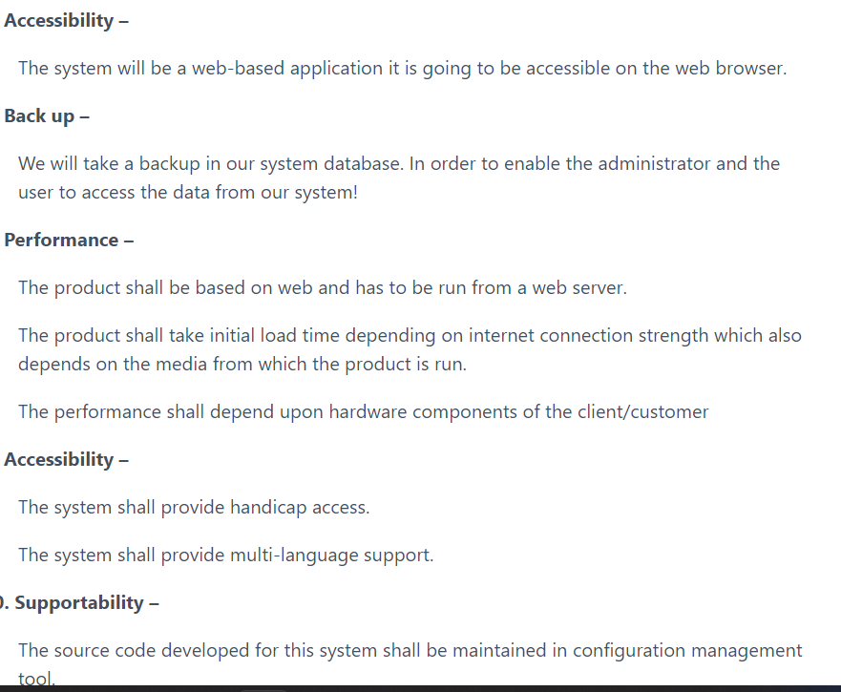

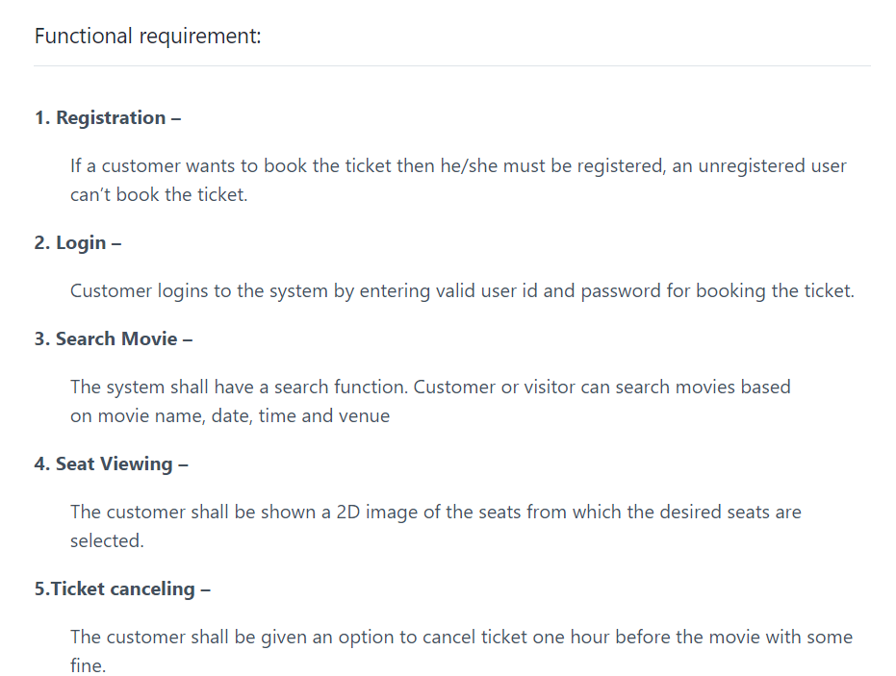

Diagram :

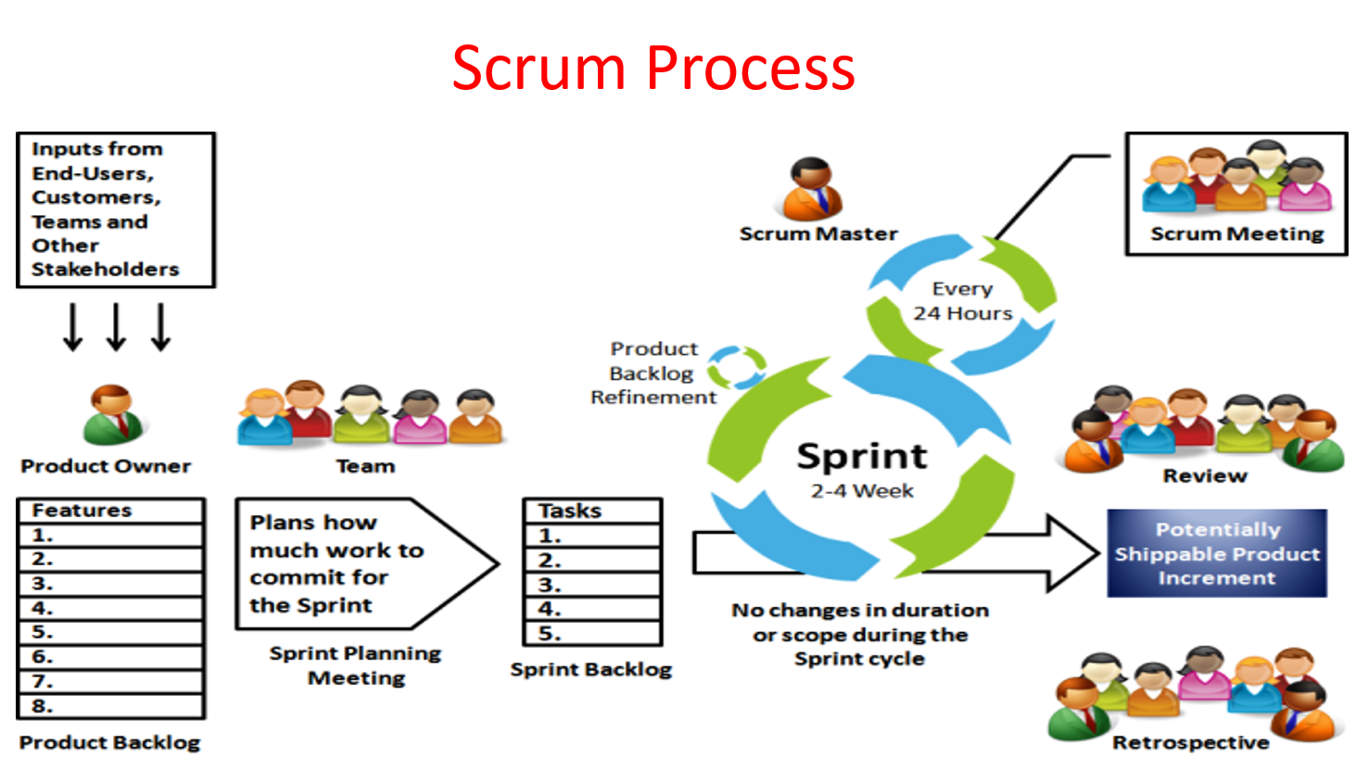

Backlogs :

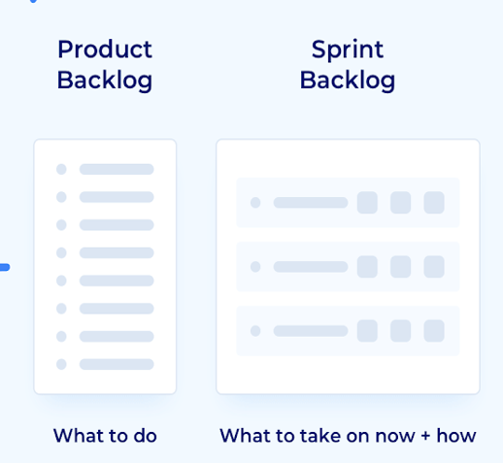

We have to write product backlogs and sprint backlogs on our own

Product backlogs lo meru oka sari u r scrum master anukondii anukunii mi team members ki em works estahroo releated to ticket booking ki avi oka 4 rayandii enough

Sprint backlog lo emoo inka koni ideas rayandii same oka 4 emo product backlog lo and inka 4 emo sprint lo ala diagram geseee .